Career Centre Event Report
Mar 4, 2024
Events in Career Center:
Job Search
1. Interview Preparation Webinar
“Approach your next interview or networking event with increased confidence. Learn how you can influence the first impression you make and show your best self while answering employers' questions.”
Mar 4, 2024 10:00 AM to 12:00 PM (Job Search)
Location: Online (see link below)

2. Resumé & Cover Letter Writing
“Find out how to effectively target your Resumé and Cover Letter. Present your experiences, education and skills in a way that showcases your assets and piques employers' interest in you.”
Mar 4, 2024 02:00 PM to 03:30 PM (Job Search)
Location: Online (see link below)

3. How to Effectively Use LinkedIn Webinar
“Wondering how using LinkedIn effectively can enhance your job search? Curious about how to leverage LinkedIn's features to build your professional network? Attend this webinar and find out!”
Mar 6, 2024 02:00 PM to 03:30 PM (Job Search)
Location: Online (see link below)

4. Black Students Careers Community: Writing Your Best Job Application (Including Resumes and Cover Letters)
“Throughout the 23/24 academic year, we'll be running career development workshops for Black students. These sessions are designed to be fun, safe, inclusive spaces, through the lens of systemic factors that affect our career decisions - designed to help you to develop your own career success.”

In this session, we'll help you to build your whole job searching profile so you can stand out! Including:
- Building a job search strategy to maximize your chances of finding opportunities suited to you
- How to build/optimize a great resume
- How to write your best cover letter
- Discovering basic skills to thrive in the professional world.
- Transferring your skills from the academic world to the professional world.
- Articulating your skills to make you stand out.
- Revisiting LinkedIn and updating your experience and posts.

Mar 7, 2024 01:30 PM to 04:00 PM (Job Search)
Location: Online (see link below)

Career Exploration

1. Personality & Career Choice Webinar
“Find out how your personality may influence your career choices and clarify important aspects of yourself through the lens of one of the world's most widely used assessments: the Myers Briggs Type Indicator (MBTI). You'll come away with an estimate of your Type but most importantly, a profile of who you are and what's most important to you in your career.”
Mar 7, 2024 10:00 AM to 11:30 AM (Career Exploration)
Location: Online (see the link below)

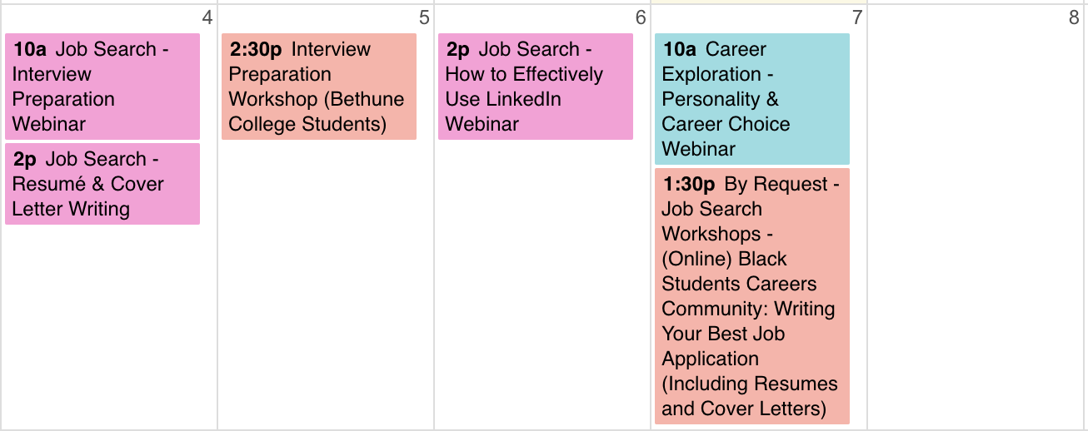

External event

Link to Career Center events (register online!):
https://experience.yorku.ca/myAccount/career/events.htm

Prepared by Chloe Liu Sun3Mar24
Approved by DA Mon4Mar24
Reviewed by IntWG

