Career Centre Event Report
Sept 04, 2023
Events in Career Center:
Job Search
1. Preparing for Career Fair Success" Resumé & Cover Letter Writing webinar
“Find out how to effectively target your Resumé and Cover Letter. Present your experiences, education and skills in a way that showcases your assets and piques employers' interest in you.”
Sep 5, 2023, 10:00 AM to 11:30 AM
Location: Online
2. Preparing for Career Fair Success"Job Search & Networking Strategies webinar
“Want to be more effective in getting the job you want? Find out how to uncover and create career opportunities by learning how employers fill job openings. Learn how to uncover hidden opportunities and build relationships that maximize your job search efforts.”
Sep 8, 2023, 10:00 AM to 11:30 AM
Location: Online
External event

1. PwC Consulting & Deals (Non-CPA)
Sep 6, 2023, 05:30 PM to 07:00 PM
Location: Off-Campus
2. Deloitte Canada
Sep 7, 2023, 05:00 PM to 05:30 PM
Location: Online
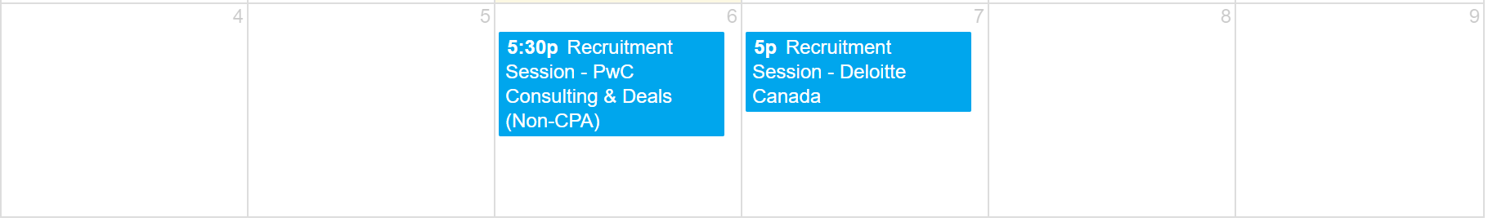

Link to Career Center events (register online!): https://experience.yorku.ca/myAccount/career/events.htm

Prepared by Jiajun Hu Sun02Sep23

Approved by

