Career Centre Event Report
Feb 26, 2024
Events in Career Center:
Job Search
1. On the Job Success (webinar)
“Learn how to create great first impressions and what to expect the first few days on the job, how to increase your chances of workplace success, and how to communicate assertively and handle difficult situations effectively.”
Feb 26, 2024 02:00 PM to 03:30 PM (Job Search)
Location: Online (see link below)

2. Preparing for the Diversity and Inclusion Recruitment Event: Resumé & Cover Letter Writing Webinar
“Find out how to effectively target your Resumé and Cover Letter. Present your experiences, education and skills in a way that showcases your assets and piques employers' interest in you.”
Feb 27, 2024 10:00 AM to 12:00 PM (Job Search)
Location: Online (see link below)

3. Ways to Make Money While Studying
“Are you looking for ways to make money and gain experience? Learn about a variety of sources for on or off campus opportunities and get familiar with the process to apply! Attend this webinar and find out.”
Feb 28, 2024 03:00 PM to 04:00 PM (Job Search)
Location: Online (see link below)

4. Preparing for the Diversity and Inclusion Recruitment Event: Job Search and Networking Strategies webinar
“Want to be more effective in getting the job you want? Find out how to uncover and create career opportunities by learning how employers fill job openings. Learn how to uncover hidden opportunities and build relationships that maximize your job search efforts.”
Feb 29, 2024 10:30 AM to 12:30 PM (Job Search)
Location: Online (see link below)

5. Resumé & Cover Letter Writing webinar
“Find out how to effectively target your Resumé and Cover Letter. Present your experiences, education and skills in a way that showcases your assets and piques employers' interest in you.”
Mar 1, 2024 11:00 AM to 12:30 PM (Job Search)
Location: Online (see link below)

Career Exploration

1. Personality & Career Choice webinar
“Join this webinar to find out how your personality may inluence your career choices and clarify important aspects of yourself, through the lens of the Myers Briggs Type Indicator (MBTI), one of the most widely used assessments in the world. You'll come away with an estimate of your Type and a better understanding of what is important to you in your career.”
Feb 27, 2024 02:00 PM to 03:30 PM (Career Exploration)
Location: Online (see the link below)

Career Conversations

1. T.A.S.T.E (Talk About Studies To Employment) Program Orientation Session

“The objective of the T.A.S.T.E Mentoring Program is to provide York Students and new graduates with an opportunity to connect with professionals in their field of interest. During the meeting, the mentor shares information about their job, industry, and organization, and students get the opportunity to ask questions, receive guidance, and gain industry insights.”

Feb 28, 2024 04:00 PM to 04:30 PM (Career Conversations)
Location: Online (see the link below)

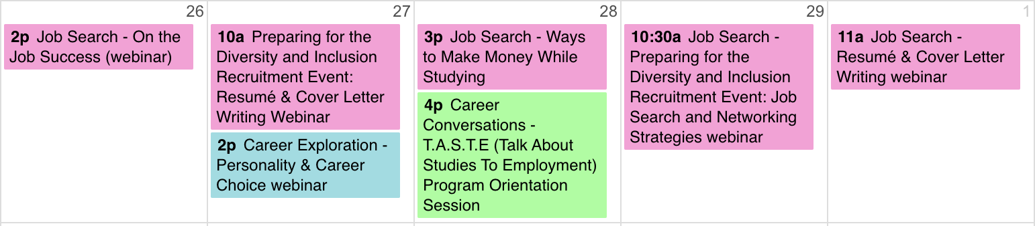

External event

Link to Career Center events (register online!):
https://experience.yorku.ca/myAccount/career/events.htm

Prepared by Chloe Liu Sun25Feb24
Approved by DA Mon26Feb24
Reviewed by IntWG

