Career Centre Event Report
Feb 12, 2024
Events in Career Center:
Job Search
1. Job Search and Networking Strategies Webinar
“Want to be more effective in getting the job you want? Find out how to uncover and create career opportunities by learning how employers fill job openings. Learn how to uncover hidden opportunities and build relationships that maximize your job search efforts.”
Feb 13, 2024 11:00 AM to 11:30 AM (Job Search)
Location: Online (see link below)

Career Exploration
1. Designing a Meaningful Career for Masters and PhD Students Webinar
“This webinar is customized for graduate and PhD students.
Join this webinar to learn how to develop a holistic approach to your career exploration and career wellness planning as a graduate student. You will be introduced to York's Career Decision Making Model, online resources, and the range of hybrid supports the Career Centre provides to help you create a meaningful future. In partnership with the Faculty of Graduate Studies (FGS).”
Feb 12, 2024 10:00 AM to 11:00 AM (Career Exploration)
Location: Online (see link below)

2. How to Make Career Decisions Webinar
“Are you feeling stuck with your career decision making and not sure how to move forward? Attend this webinar to learn the steps of making informed career decisions and how a growth mindset is essential for your personal and career success.”
Feb 12, 2024 10:00 AM to 11:00 AM (Career Exploration)
Location: Online (see link below)

3. Positive Psychology & Career Happiness Workshop
“Find a career you love. Learn principles of Positive Psychology that will enhance your personal and professional life.”
Feb 14, 2024 3:00 PM to 4:00 PM (Career Exploration)
Location: Career Lounge York Lanes across from the Bookstore

Career Conversation
1. York International Career Conversations Alumni Panel: Careers in Business
“Brought to you in partnership between the Career Centre and York International.
Curious to know how international students thrive in their chosen field after graduation? Have questions about the real world and the job market? Join this panel discussion to hear from former international students about their Canadian career experiences in business! The panel discussion will focus on navigating the "real world" as international alumni, tips and tricks that helped them find success, and more! The panel discussion will be followed by an open forum where students will have an opportunity to ask the panelists their own questions.”
Feb 13, 2024 5:30 PM to 7:00 PM (Career Conversations)
Location: Online (see link below)

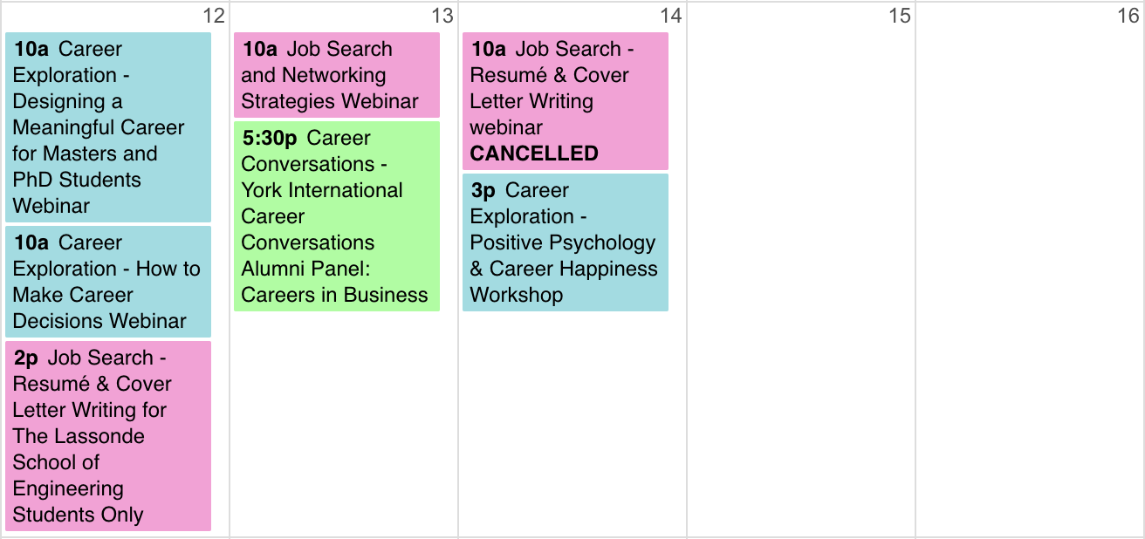

External event

Link to Career Center events (register online!):
https://experience.yorku.ca/myAccount/career/events.htm

Prepared by Chloe Liu Sun11Feb24

Approved by DA Mon12Feb24

Reviewed by IntWG

