Career Centre Event Report
Feb 5, 2024
Events in Career Center:
Job Search
1. Resumé & Cover Letter Writing
“Find out how to effectively target your Resumé and Cover Letter. Present your experiences, education and skills in a way that showcases your assets and piques employers' interest in you.”
Feb 5, 2024 02:00 PM to 03:30 PM (Job Search)
Location: Online

2. Interview Preparation
“Approach your next interview or networking event with increased confidence. Learn how you can influence the first impression you make and show your best self while answering employers' questions.”
Feb 6, 2024 02:00 PM to 04:00 PM (Job Search)
Location: Online

3. How to Effectively Use LinkedIn
“Wondering how using LinkedIn effectively can enhance your job search? Curious about how to leverage LinkedIn's features to build your professional network? Attend this webinar and find out!”
Feb 8, 2024 10:00 AM to 11:30 AM
Location: Online

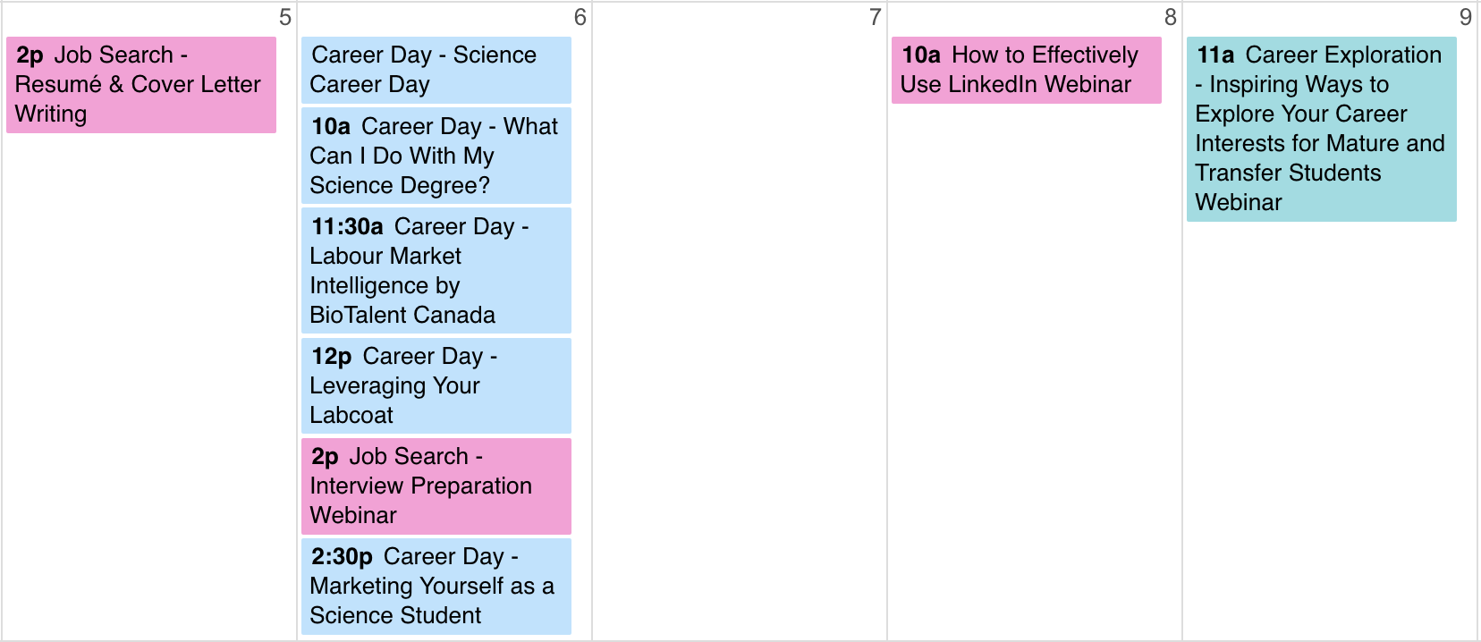

External event

Link to Career Center events (register online!):
https://experience.yorku.ca/myAccount/career/events.htm

Prepared by Chloe Liu Sun04Feb24

Approved by DA Mon05Feb24

Reviewed by IntWG

